# **TASK BUDDY:**

TaskBuddy is a responsive task management application developed using React, designed to help users efficiently create, organize, and track their tasks. The application features user authentication via Firebase, allowing seamless Google sign-ins.

TaskBuddy ensures a seamless and organized task management experience, providing users with greater productivity and clarity in tracking their tasks.

**LOGIN SCREEN:**

The login screen contains the continue with google button where the user is authenticated via Firebase.

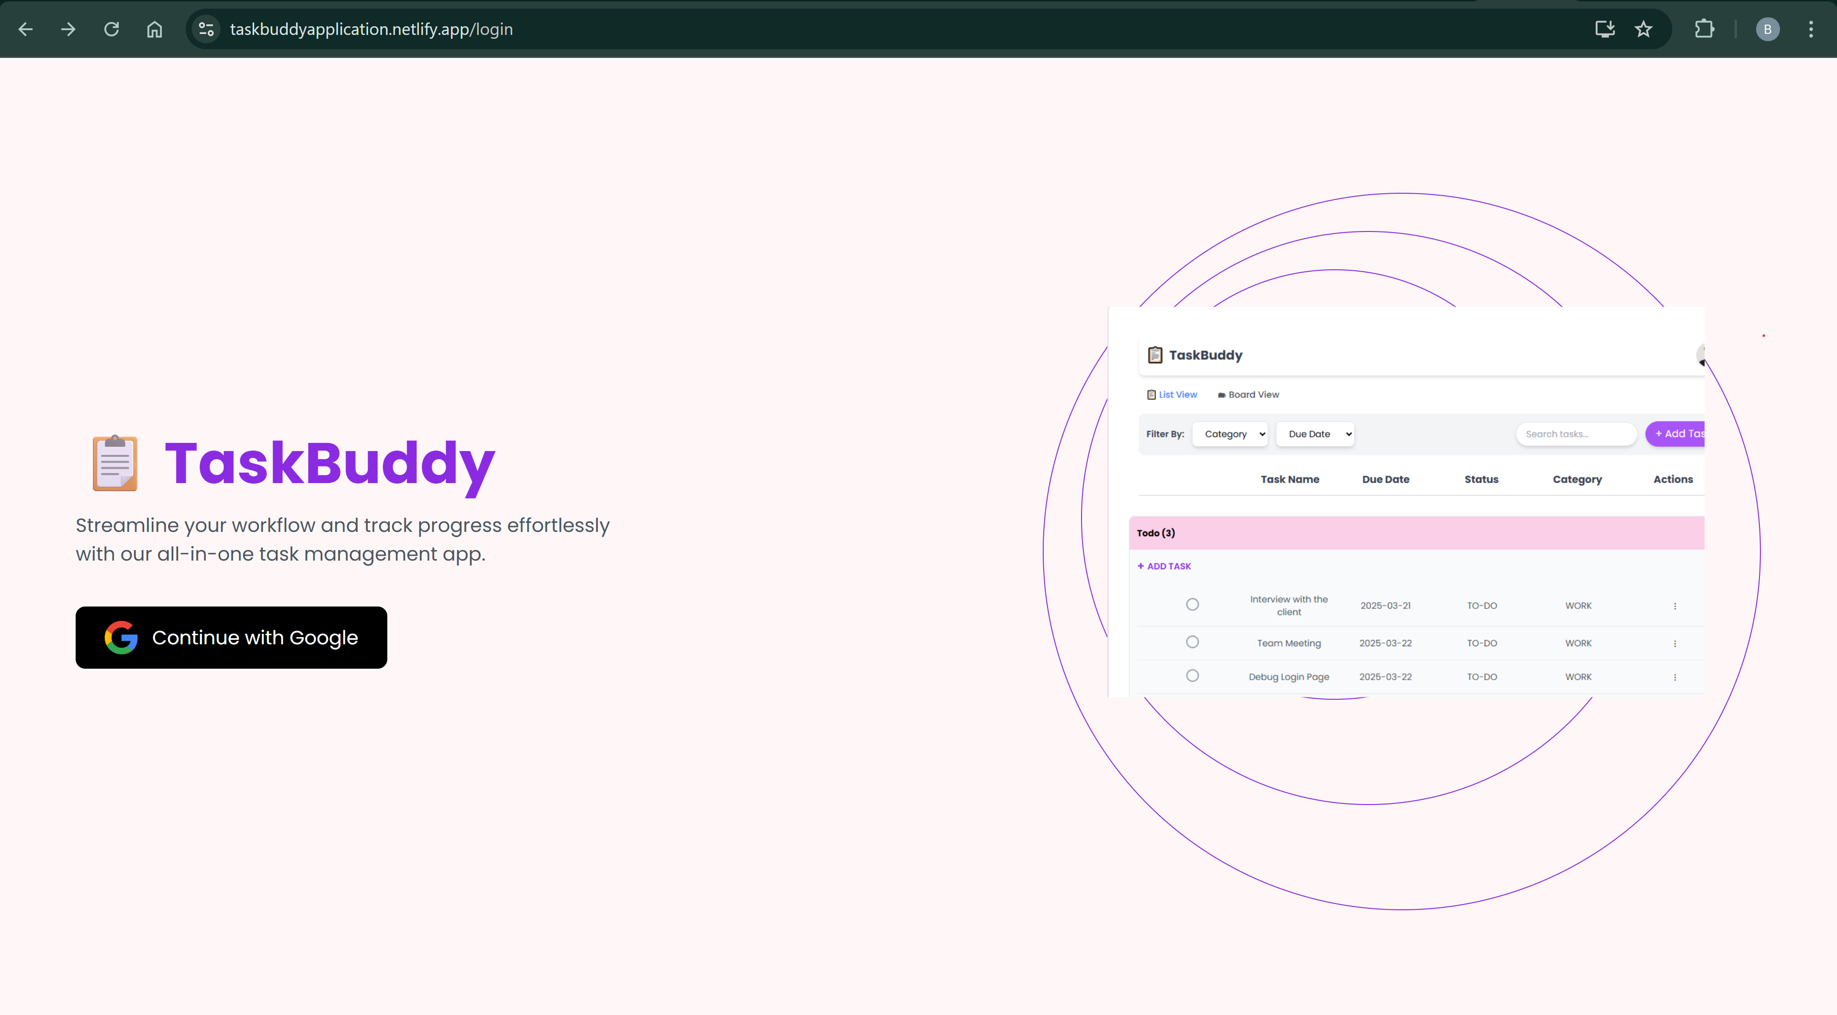

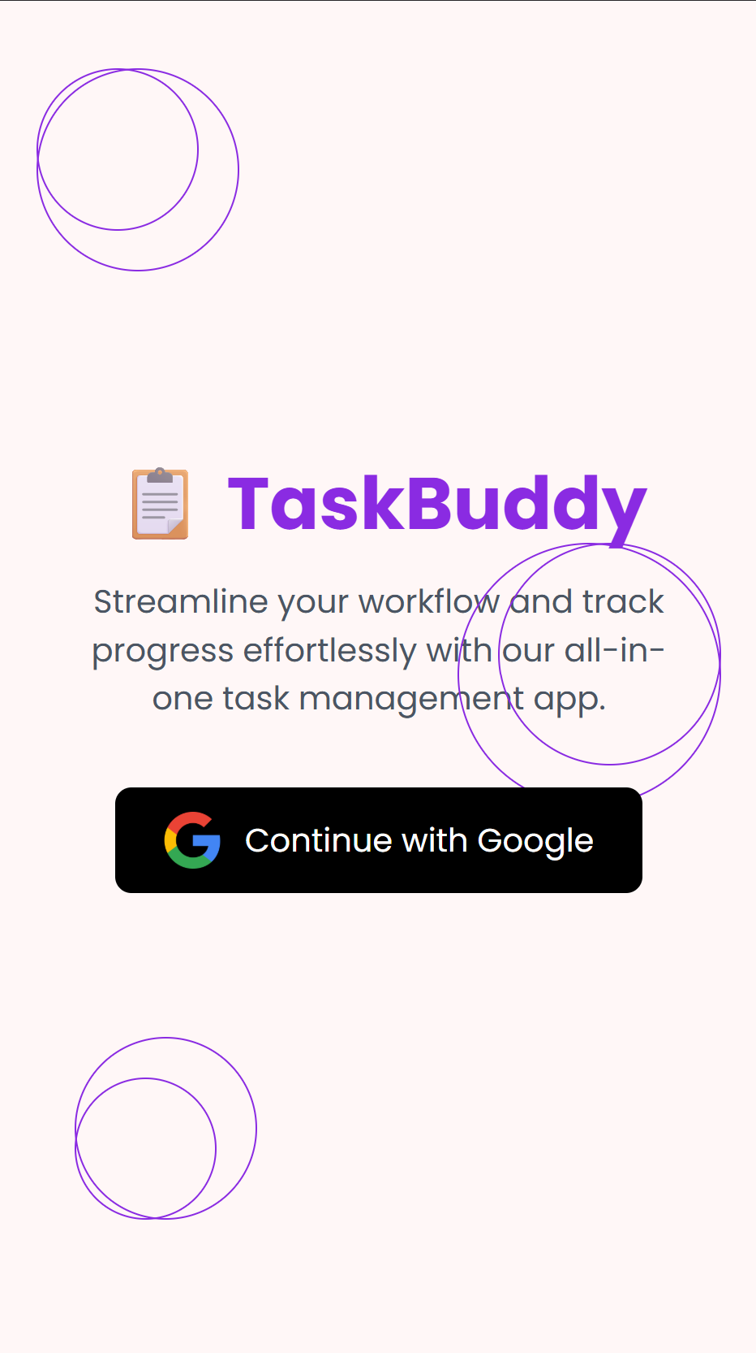



**TASK LIST:**

* TaskBuddy offers a task list view where tasks are categorized as TO-DO, IN-PROGRESS, or COMPLETED.
* Users can create, edit, and delete tasks, categorize them (e.g., work, personal), and set due dates.
* The list view supports batch actions like changing the status or deleting multiple tasks using checkboxes.
* Users can drag and drop tasks across different columns to update their status.
* Tasks can be sorted in ascending or descending order based on their due dates.
* Inline task addition is supported for a more efficient task management experience.

# 

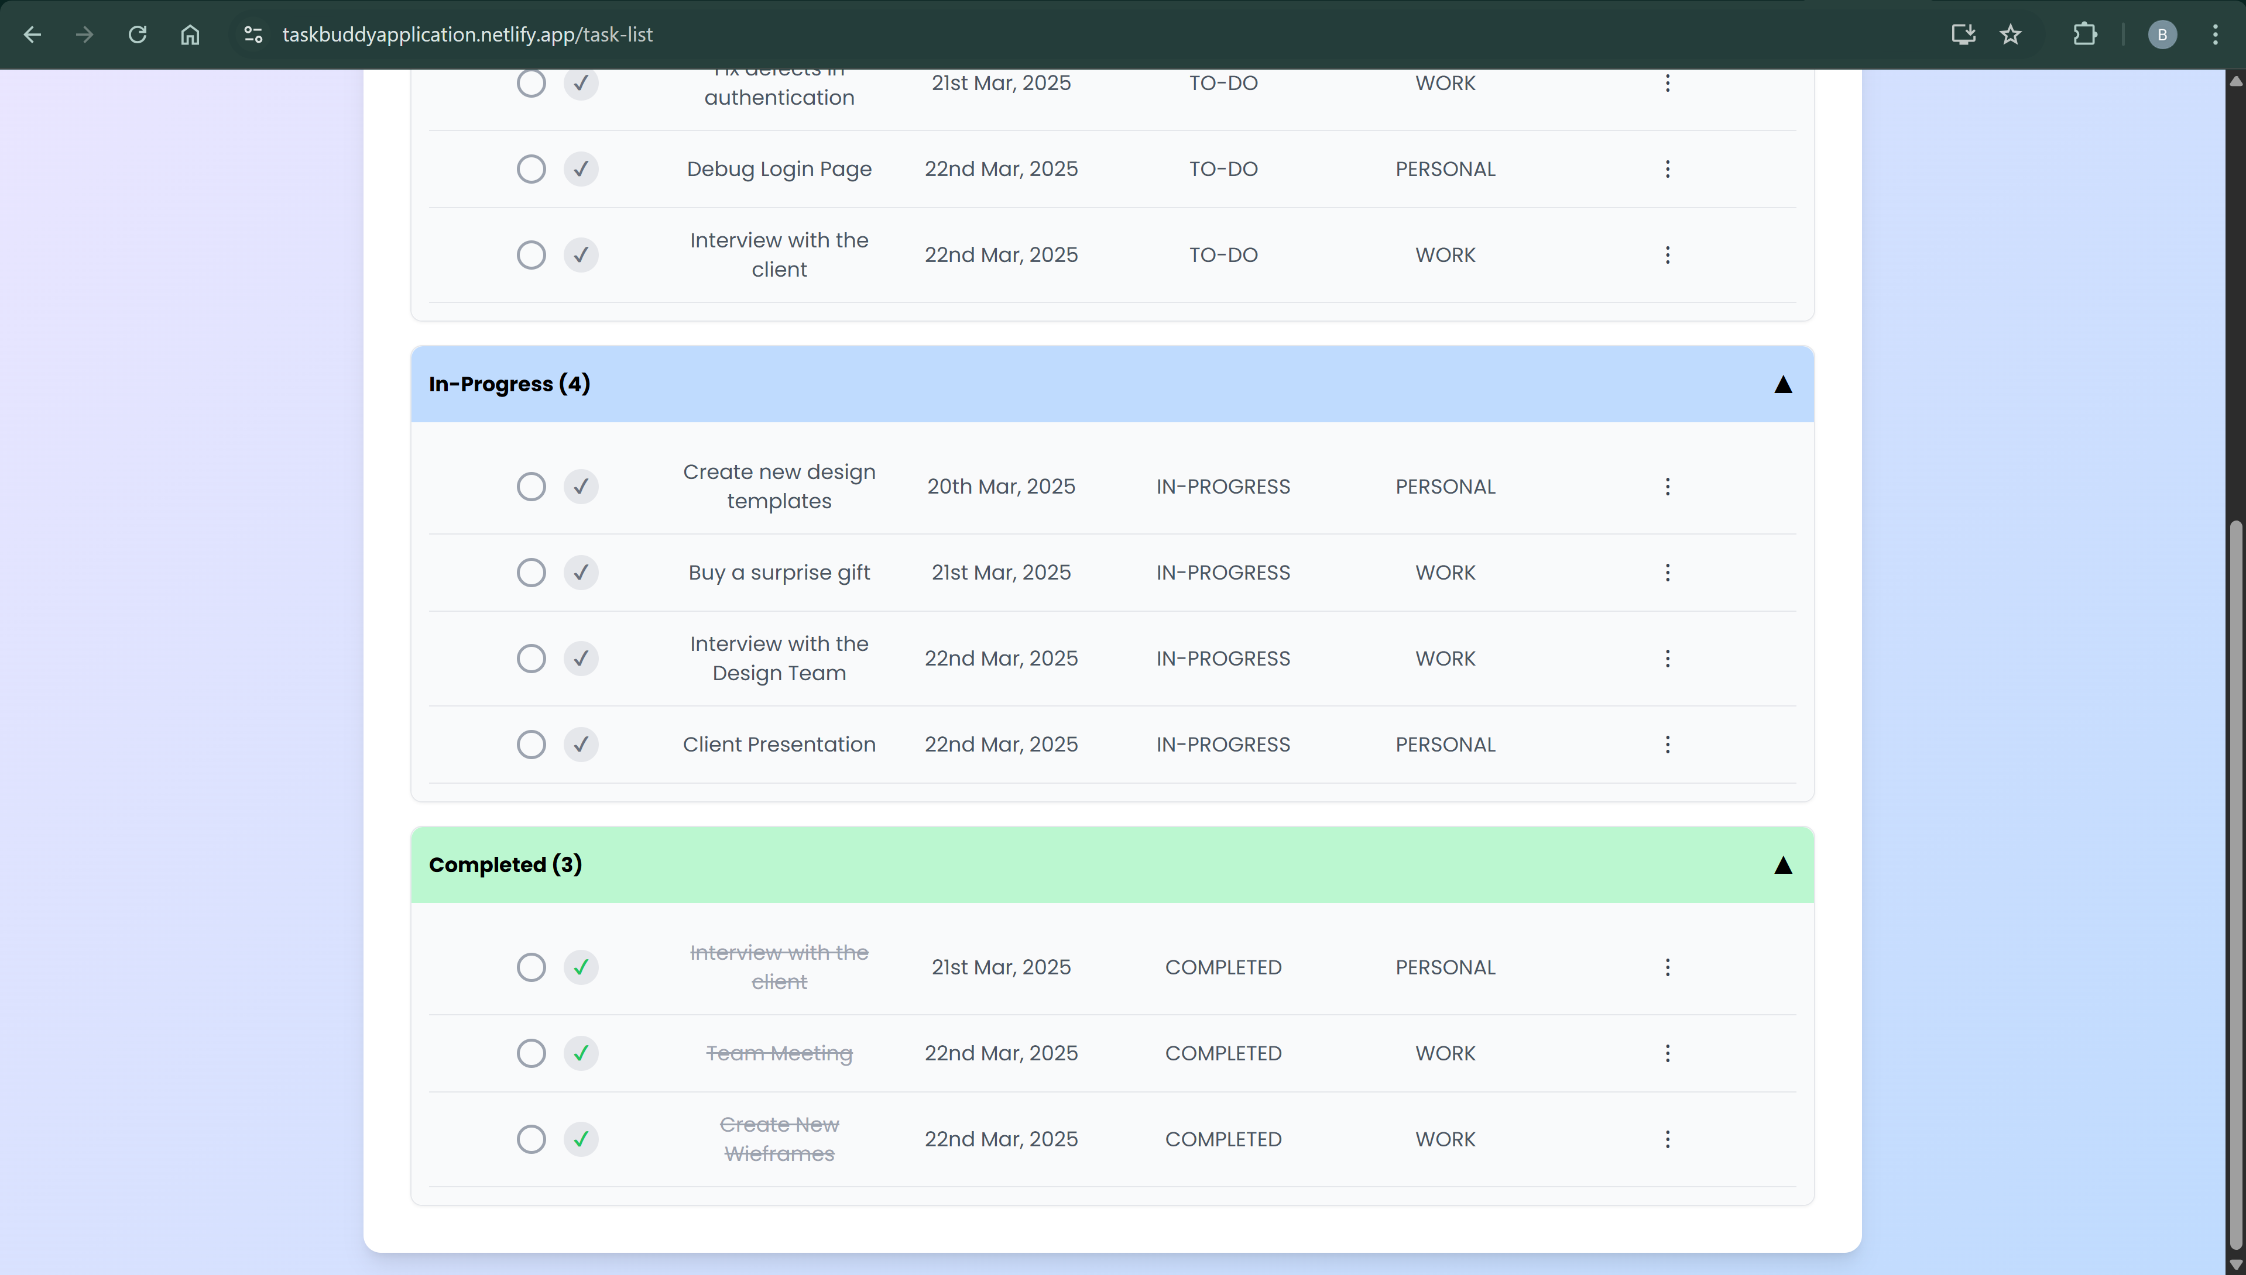

**INLINE TASK ADDITION IN THE TASK LIST:**

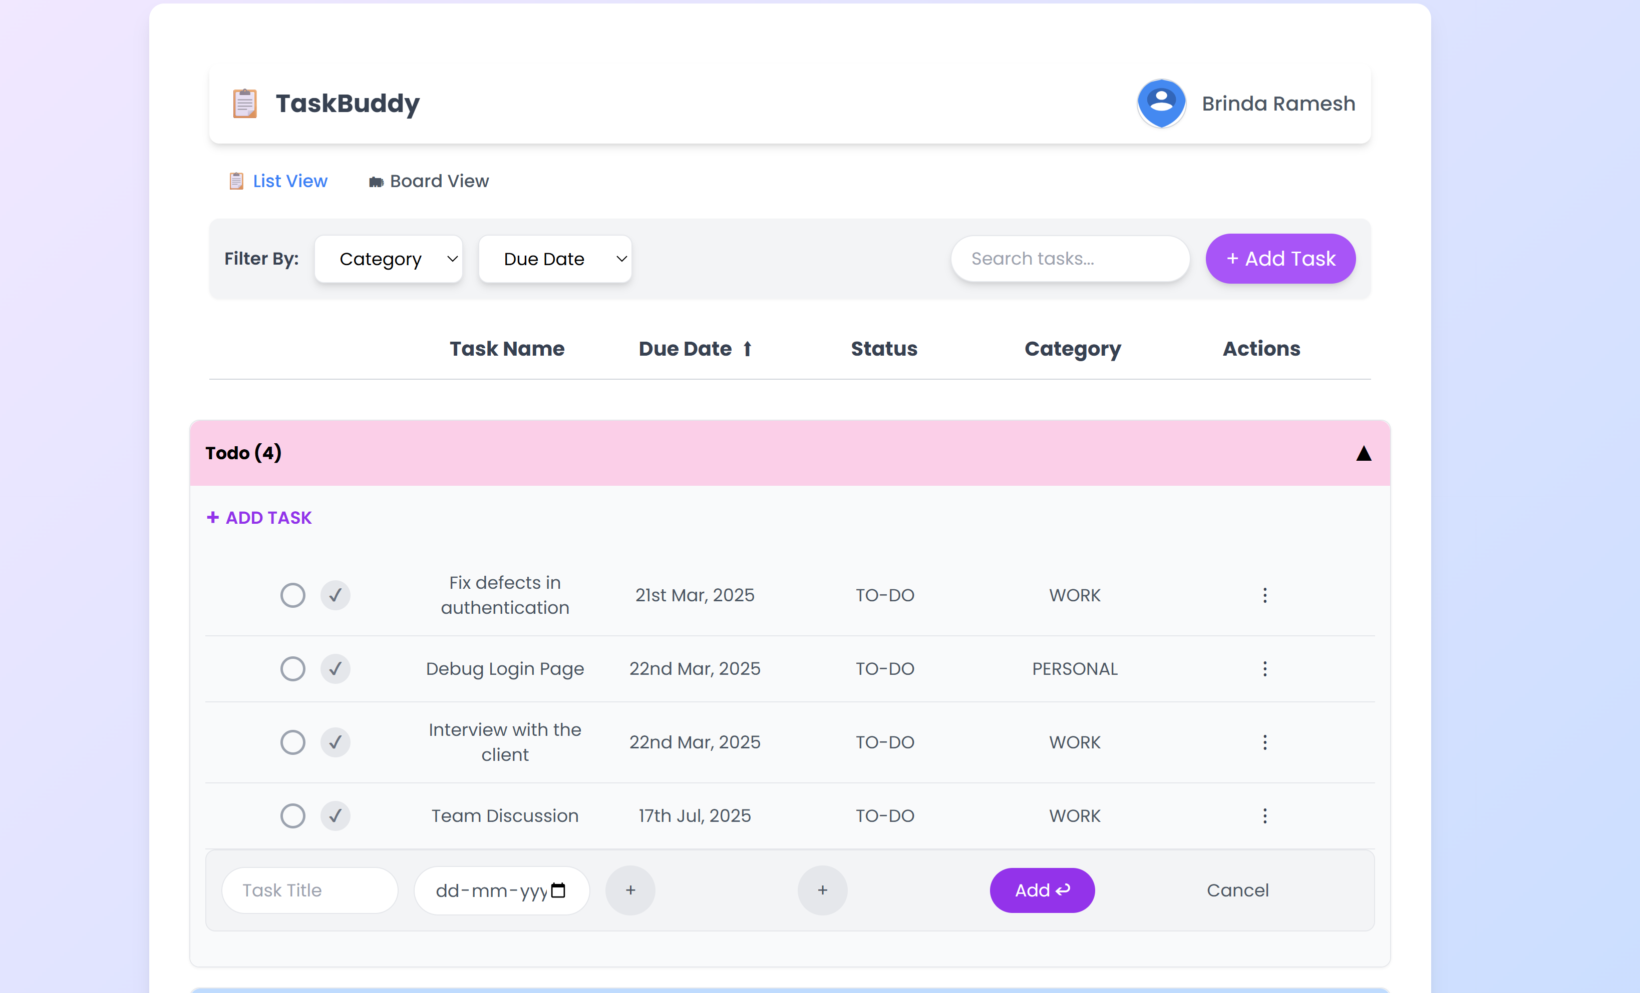

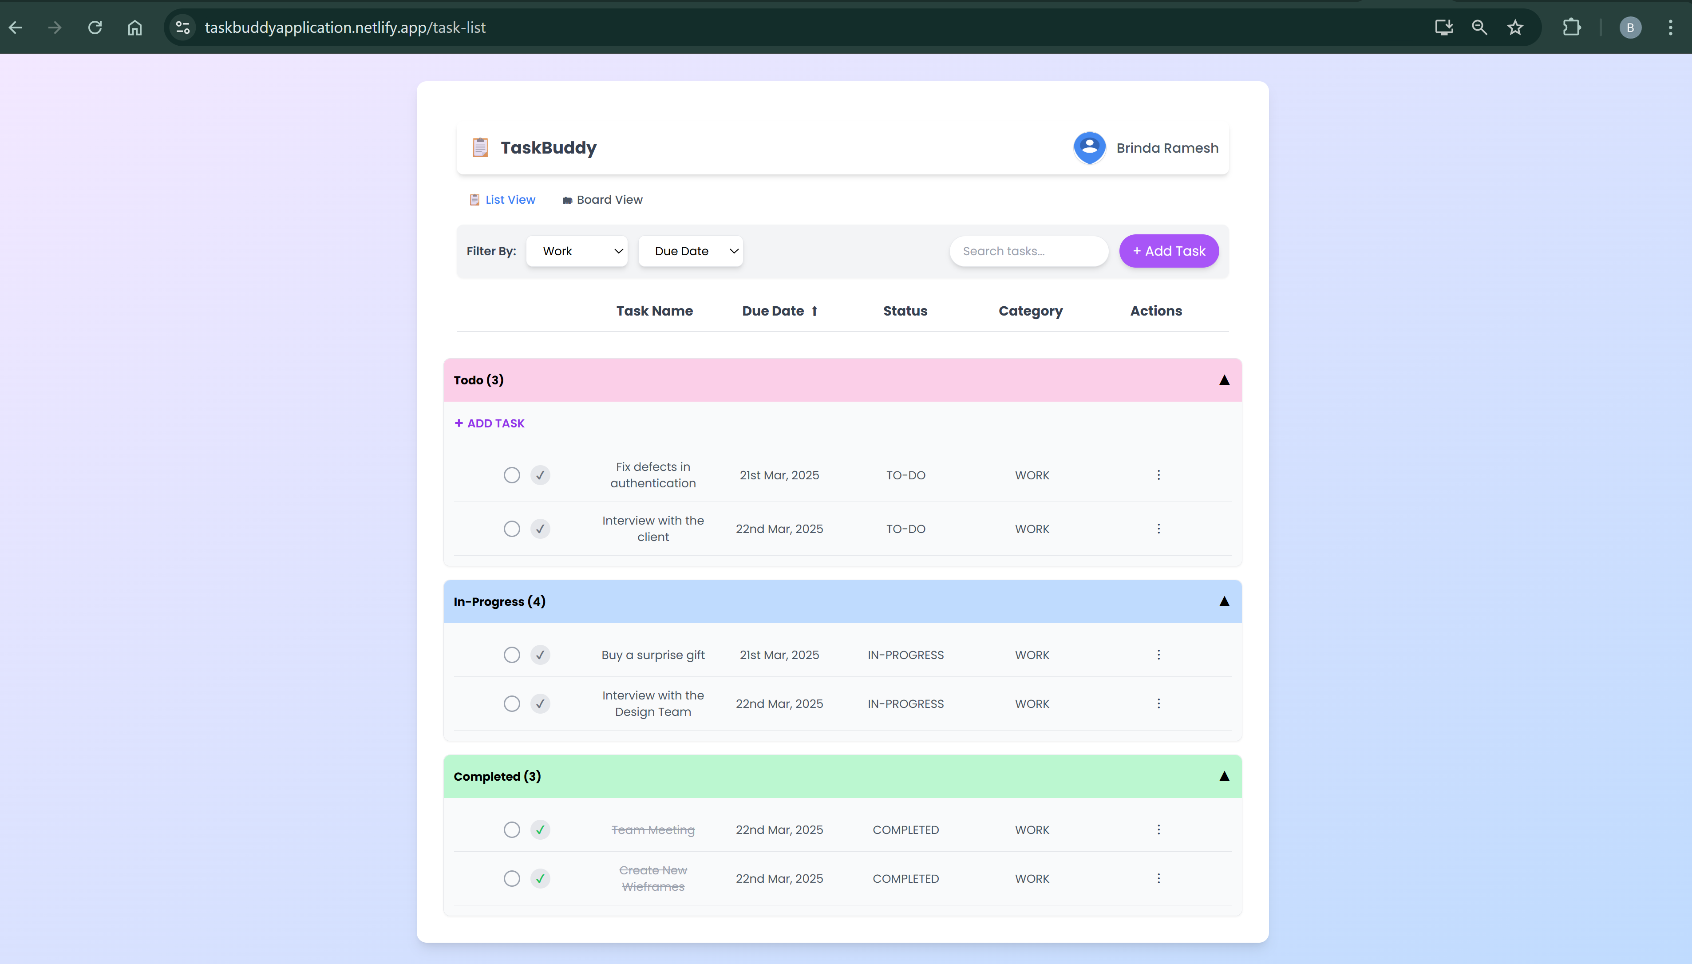

**Add Modal:**

* The add modal lets users create new tasks by entering task details such as name, status, category, description, and attachments.
* Mandatory fields are marked with an asterisk (*), and the submit button remains disabled until all required fields are completed.

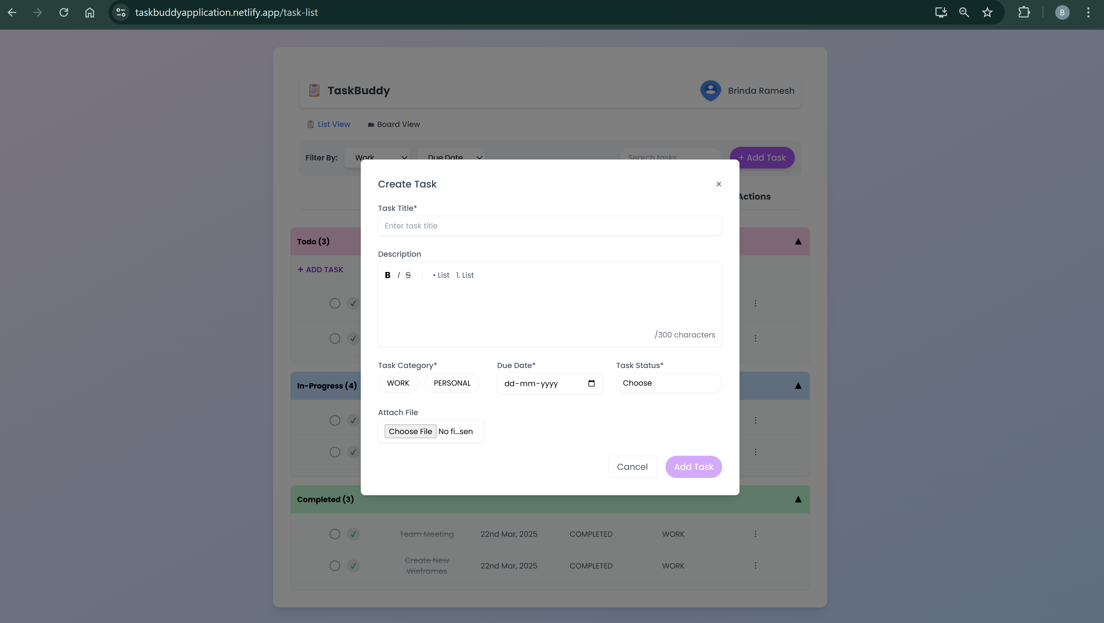

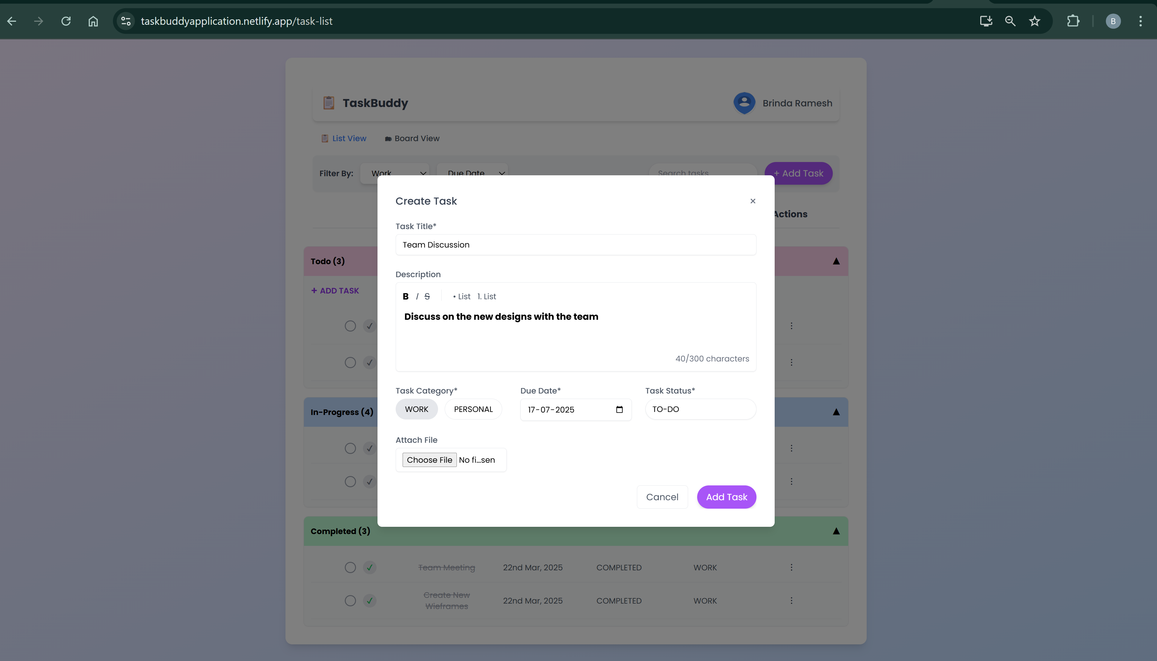

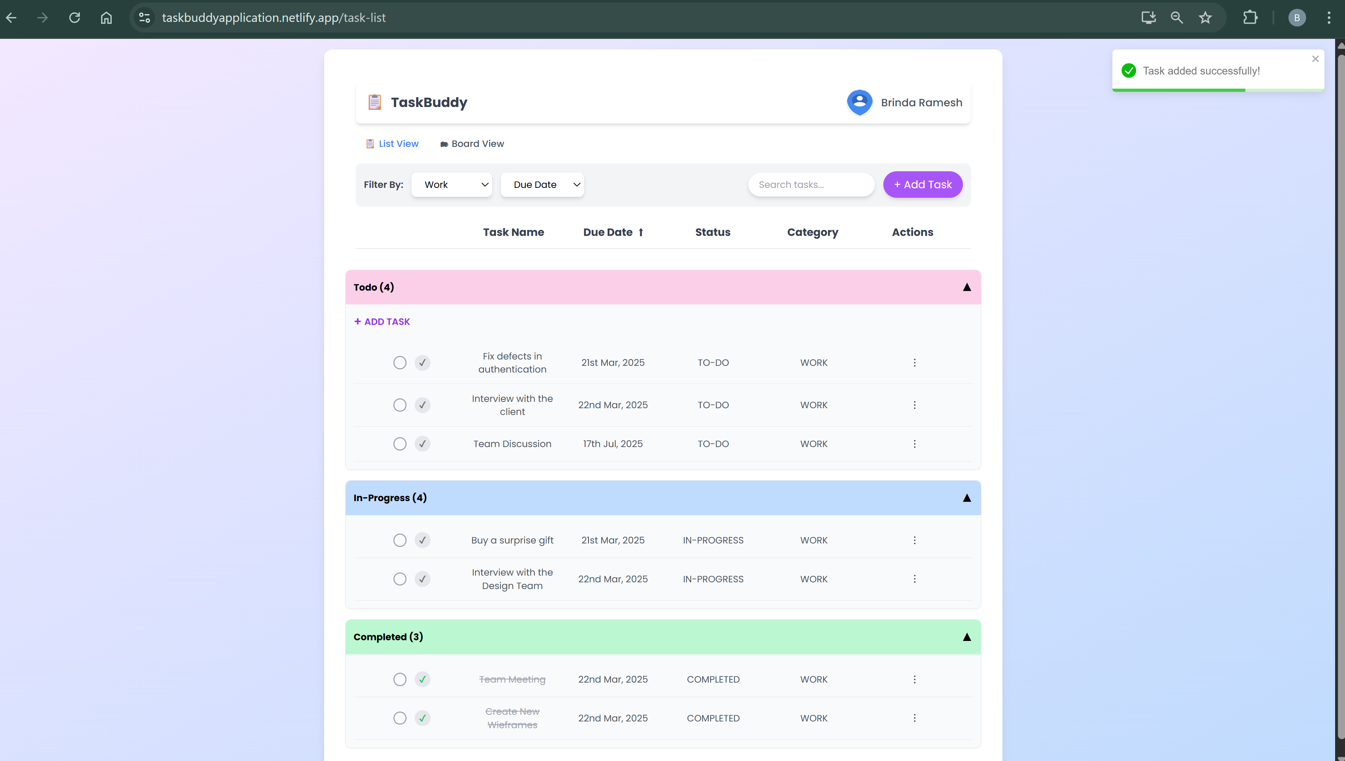

**Edit Modal:**

* The edit/view modal allows users to view or edit the details of a selected task.
* Users can track task changes using an activity log that records task creation, status updates, and attachment additions.
* Users can also attach files or documents to tasks for additional context.

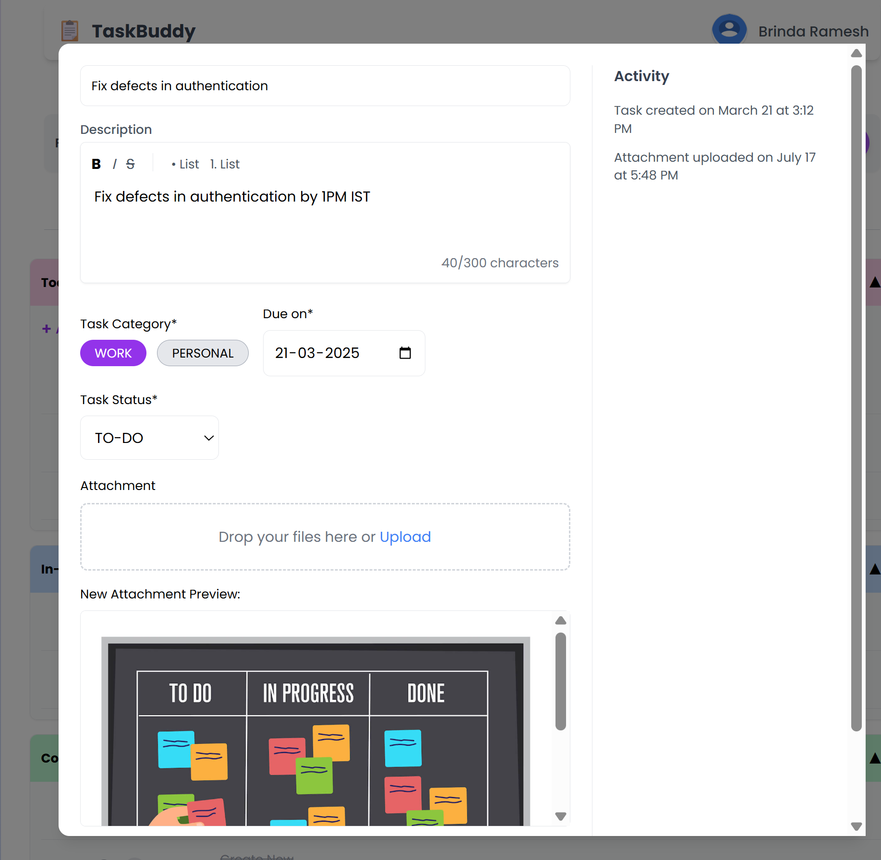

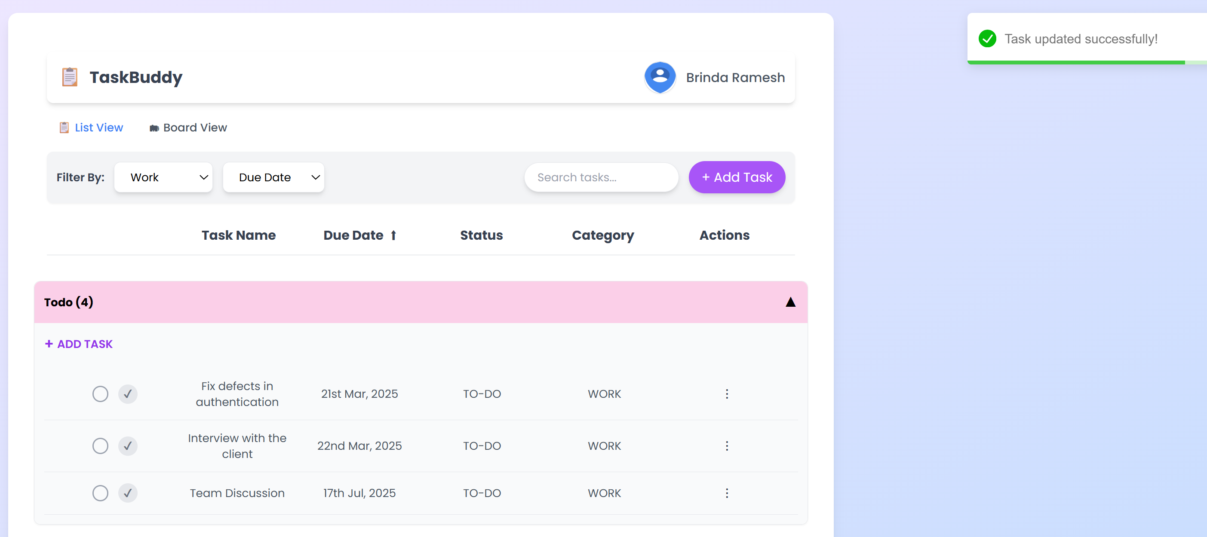

**BATCH UPDATE:**

Users can select or deselect multiple tasks using checkboxes and perform batch actions such as updating status or deleting selected tasks.

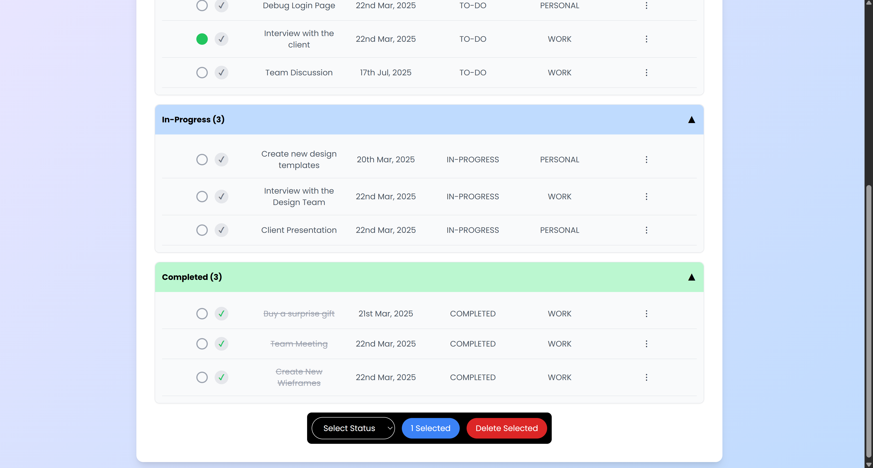

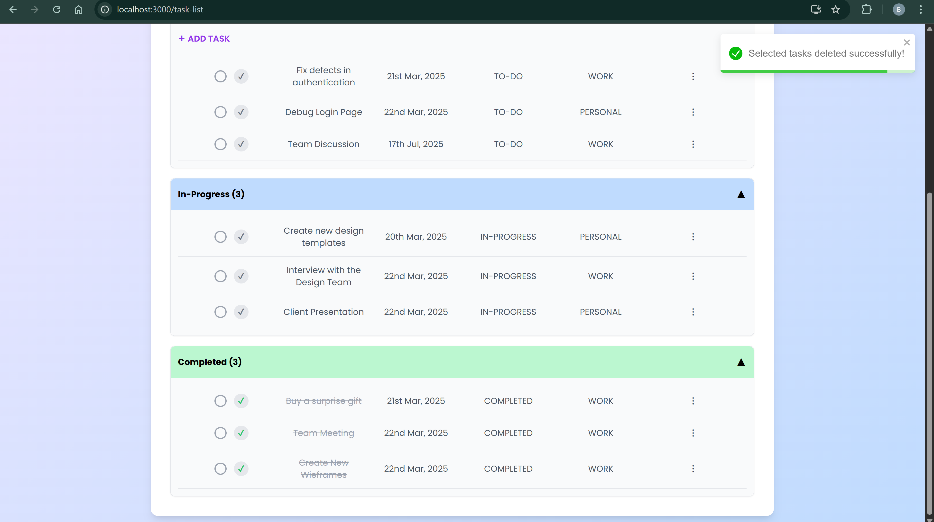

**Task Board:**

* TaskBuddy features a Kanban-style task board that visually organizes tasks based on their status (TO-DO, IN-PROGRESS, or COMPLETED).
* Users can perform essential actions like creating, editing, and deleting tasks directly from the board.
* Drag-and-drop functionality allows tasks to be moved between columns to update their status.
* Tasks are displayed in order of their due dates for easier prioritization.

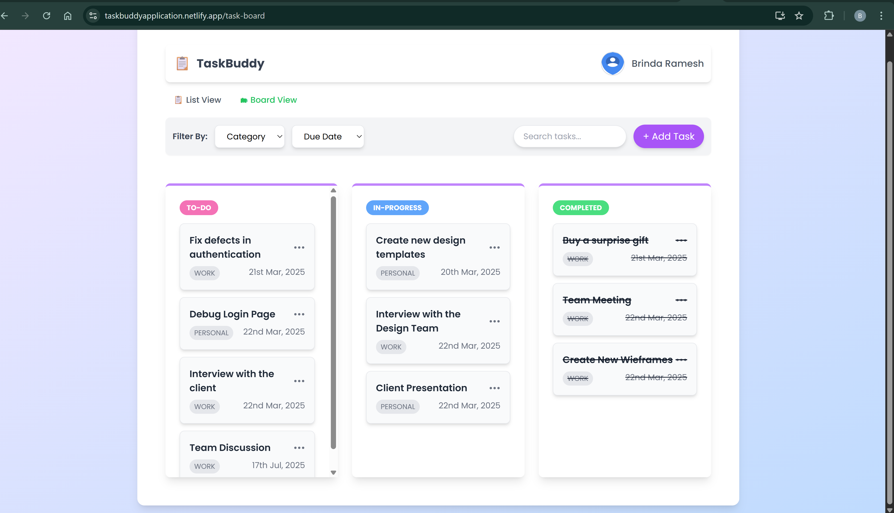

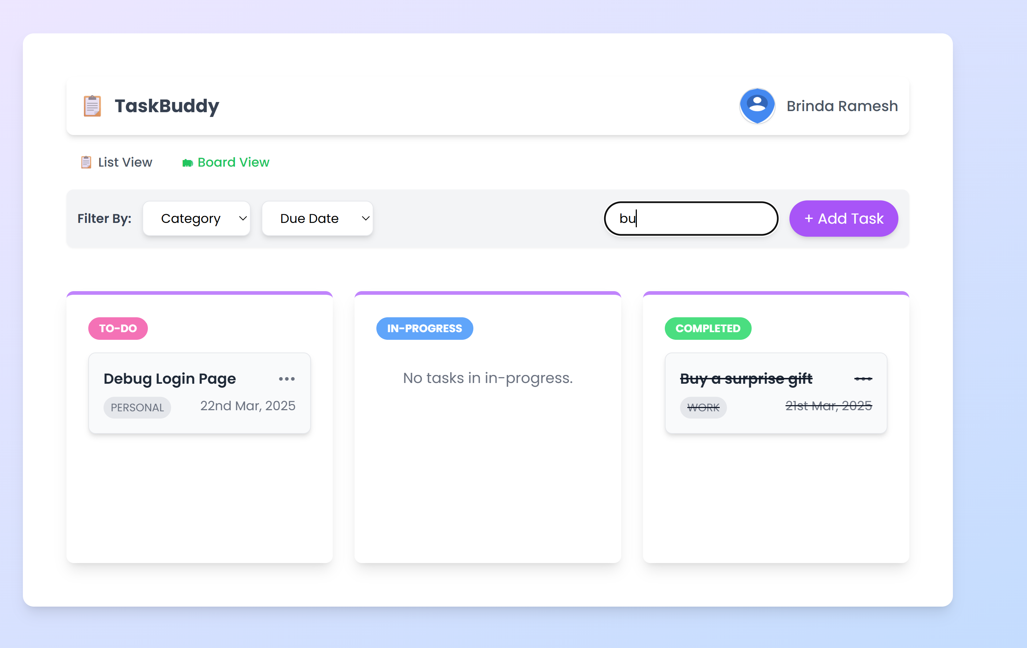

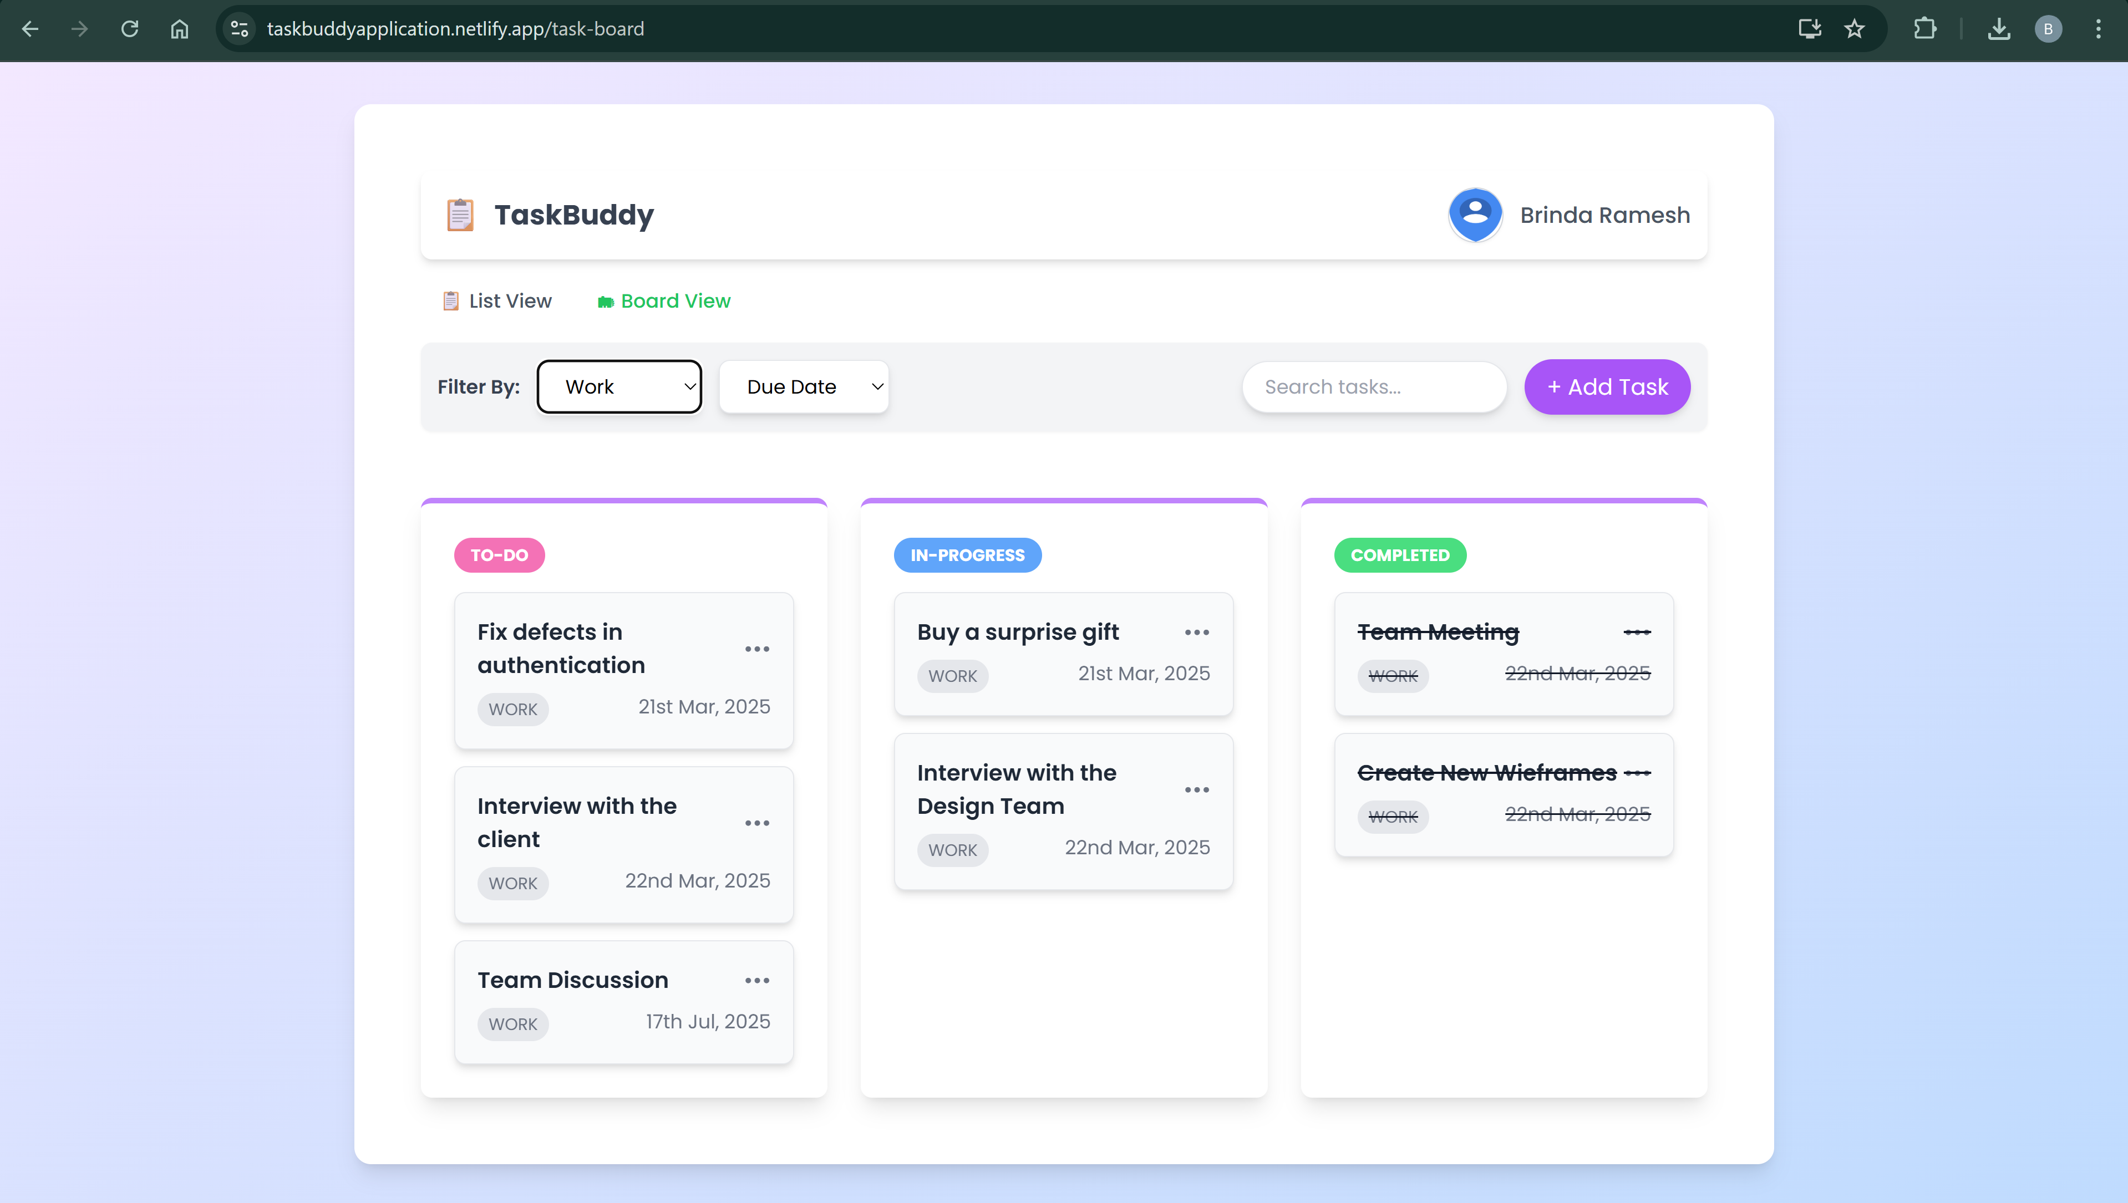

**DRAG AND DROP FUNCTIONALITY:**

Users can drag and drop tasks across columns to seamlessly update their status without opening the edit modal, providing a smooth and intuitive user experience.

**TASK BOARD:**

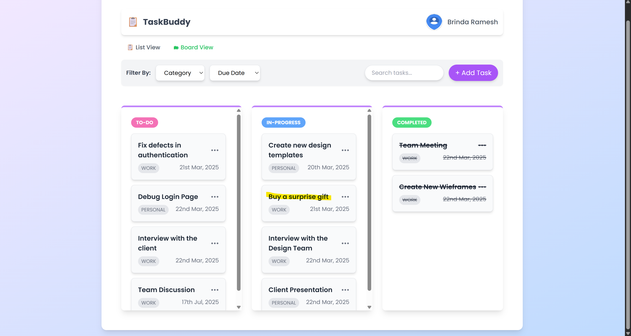

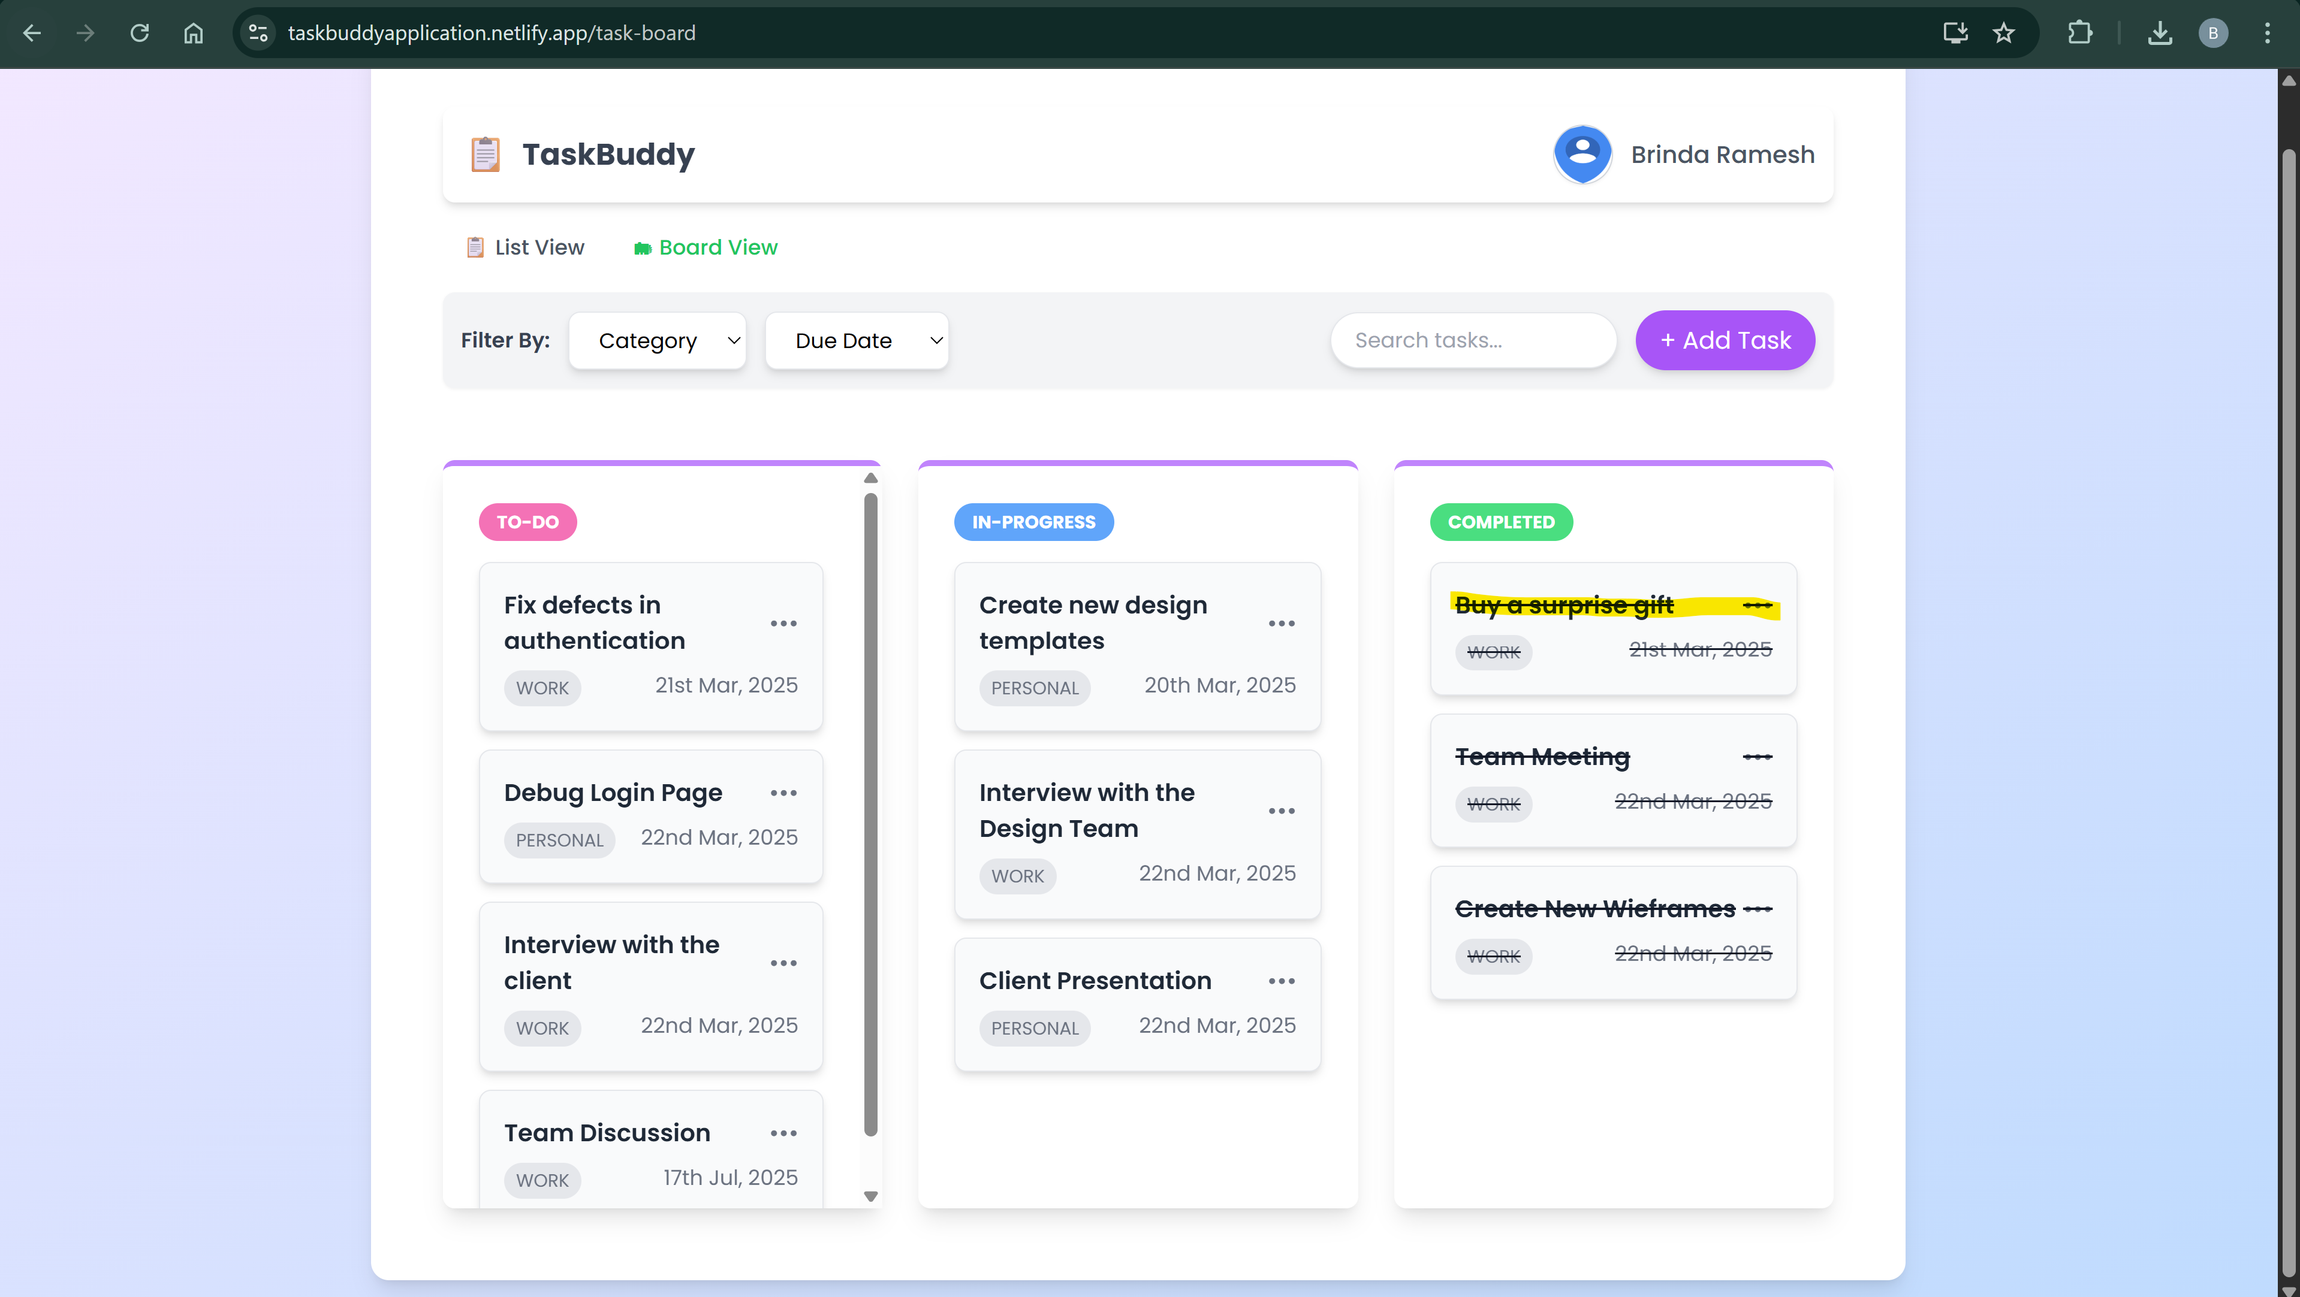

**TASK LIST:**

